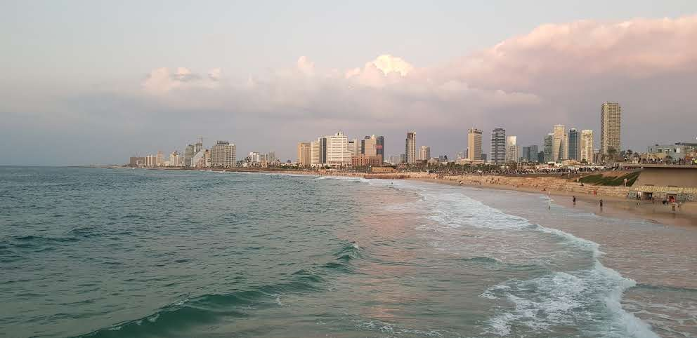
Tel Aviv Meeting – 2nd-3rd May, 2023

In association with
The Israeli Bar Association

• Sponsors : Israeli Bar Association , Aon Israel Brokerage Ltd, Howden Tiger Reinsurance Israel, Levitan, Sharon & Co Law Firm, Gross, Orad, Schlimoff & Co. Law Firm , Harlap Law Firm

Program*

*All panels and lectures will be with simultaneous translation (Hebrew-English)

Venue: The Bar Association Building, 10 Daniel Frisch Str. Tel Aviv

2nd May, 2023

- 9:00-9:30 Gathering and light refreshment

- 9:30-9:45 Opening– Welcome greetings:
Adv. Amit Bachar, Head of Israeli Bar Association
Adv. Leon Amiras, Head of Foreign Relations, Israeli Bar Association
Adv. Peggy Sharon, AIDA World President
_____________________________________________________________

- 9:45-10:30 Guest Speaker: Kobi Bendelak, Israeli Insurtech, start-ups and innovations in Insurance
___________________________________________________________

- 10:30-11:15 Insurance and Reinsurance Hot Topics
Moderators: Prof. Jérôme Kullmann, France. Honorary President of AIDA World, and Dr. Carlos Estebenet, Argentina.
Panel speakers:
Adv. Orli Naschitz from Naschitz, Brandes, Amir & Co. :Hot topics in Reinsurance,
Adv. Shimon Katz from Y. Katz, S. Katz & C0. : The inherent Conflict of Interests between Insurer and Insured , how should the lawyer behave?
Elad Shelef, from Howden Tiger Israel, Reinsurance Brokers : The Reinsurance Market on a Crossroad
________________________________________________________________
- 11:15-12:00 The Insurance Contract – a specific arrangement in favor of the Insured, or - a Contract?
Moderator: Prof. Ronen Avraham Tel Aviv University.
Panel Speakers:
Adv. Peggy Sharon from Levitan, Sharon & Co.,
Adv. Haim Kalir from Haim Kalir & Co.
___________________________________________________________

- 12:00-12:45 Motor vehicle, Autonomous Cars, and Parametric Insurance – Moderator: Prof. Sara Landini, Italy.
Panel Speakers:
Prof. Simona Viciani, University of Florence :"Parametric insurance and smart mobility" ,
Adv. Ilan Kaner from Kaner-Bastakar Law Firm: Definition of "Motor Vehicle" and "The use of motor vehicle" in Israel,
Adv. Assaf Warsha, from Warsha Assaf & Co. Law Firm :"Insurance of Electric Scooters".
__________________________________________________

- 12:45-13:00 End of today's conference
_______________________________________________________

- 13:30-16:00 AIDA World Executive Committee Meeting

- 18:30 Welcome Cocktail for AIDA World PC members

3rd May, 2023
- 09:00-09:30 Gathering and light refreshment

- 09:30-10:15 Financial Insurance– D&O Insurance and Cyber
Moderator: Prof. Robert Koch, Hamburg University, Germany.
Panel Speakers:
Adv. Moshe Abady, from Levitan, Sharon & Co. Law firm,
Adv. Orit Amiran-Sinn from Gross, Orad, Schlimoff Law Firm,
Adv. Yoav Razin , from Naschitz, Brandes, Amir & Co. Law Firm.
__________________________________________________________

- 10:15-11:00 Cyber Events - What has changed and where are we going? Insurance Perspective
Moderator: Adv. Sigal Schlimoff from Gross, Orad, Schlimoff & Co. Law Firm
Panel Speakers:
Adv. Yael Navon from Levitan, Sharon & Co. Law firm,
Adv. Yoran Gil from Yigal Arnon & Co. Law Firm,
Eddie Aviad, from Aon Israel Insurance Brokerage Ltd.
__________________________________________________________

- 11:00-11:25 New Technologies
Moderator: Prof. Andrea Signorino, Uruguay, AIDA World General Secretary
Panel Speakers :
Adv. Gabriel Vivas, Columbia, Accidents of Electric cars
Adv. Erez Schneorson ,from E. Schneorson, Diav & Co.: Which Insurance covers Third Parties' Damage caused by a fire of an electric car while being Charged?
____________________________________________________________
- 11:25-11:50 General Principles of Insurance – New Tendencies re Precontractual Disclosure Duties
Moderator: Prof. Margarida Lima Rego, Portugal
Panel Speakers :
Adv. Azriel (Zili) Rothman, from Naschitz, Brandes, Amir & Co:
The deductible in a Third Party claim against the Liability insurer
Adv. Keren Tagar, from Mordechai Tagar Law firm : Professional Liability Insurance - Is the Insurer bound by the Insured's contract with its Client?

______________________________________________
- 11:50-12:40 Catastrophes and Climate Events –
Moderator: Adv. Chris Rodd, Australia
Panel Speakers:
Adv. Assaf Elrom from Elrom, Rom, Salomon & Co.: Sinkholes – who will cover the damage?
Adv. Eran Yakobovitch from Zvi Yakobovitch Law firm : Covid 19 claims, Adv. Omer Harlap from Harlap Law Firm :Earthquake Insurance
________________________________________________________
Closing Speech – Adv. Peggy Sharon
_____________________________________________________________

- 13:30-16:00 AIDA World Presidential Council Meeting
- 19:30 Dinner- AIDA World PC at Old Jaffa Restaurant

j:\1678\1-390526

1678\390744

